Module-3
sameerashaik1005@gmail.com
Exercise 1: Ranking and Window Functions :
Goal: Use ROW_NUMBER(), RANK(), DENSE_RANK(), OVER(), and PARTITION BY.

CREATE DATABASE OnlineRetailStore;
USE OnlineRetailStore;

CREATE TABLE Products (
ProductID INT PRIMARY KEY,
ProductName VARCHAR(100),
Category VARCHAR(50),
Price DECIMAL(10,2)
);
INSERT INTO Products VALUES
(1, 'Laptop', 'Electronics', 80000),
(2, 'Smartphone', 'Electronics', 60000),
(3, 'Tablet', 'Electronics', 40000),
(4, 'Headphones', 'Electronics', 10000),
(5, 'TV', 'Electronics', 80000),

(6, 'Sofa', 'Furniture', 50000),
(7, 'Dining Table', 'Furniture', 45000),
(8, 'Chair', 'Furniture', 10000),
(9, 'Bed', 'Furniture', 50000),
(10, 'Cupboard', 'Furniture', 30000),

(11, 'Shirt', 'Fashion', 2000),
(12, 'Jeans', 'Fashion', 3000),
(13, 'Jacket', 'Fashion', 5000),
(14, 'Shoes', 'Fashion', 4000),
(15, 'Watch', 'Fashion', 5000);

SELECT * FROM Products;

SELECT *
FROM (
SELECT ProductID,
ProductName,
Category,
Price,
ROW_NUMBER() OVER(
PARTITION BY Category
ORDER BY Price DESC
) AS RowNum
FROM Products
) AS Ranked
WHERE RowNum <= 3;

SELECT *
FROM (
SELECT ProductID,
ProductName,
Category,
Price,
RANK() OVER(
PARTITION BY Category
ORDER BY Price DESC
) AS RankNum
FROM Products
) AS Ranked
WHERE RankNum <= 3;

SELECT *
FROM (
SELECT ProductID,
ProductName,
Category,
Price,
DENSE_RANK() OVER(
PARTITION BY Category
ORDER BY Price DESC
) AS DenseRankNum
FROM Products
) AS Ranked
WHERE DenseRankNum <= 3;

SELECT
ProductName,
Category,
Price,

ROW_NUMBER() OVER(
PARTITION BY Category
ORDER BY Price DESC
) AS RowNum,

RANK() OVER(
PARTITION BY Category
ORDER BY Price DESC
) AS RankNum,

DENSE_RANK() OVER(
PARTITION BY Category
ORDER BY Price DESC
) AS DenseRankNum

FROM Products;

Output:

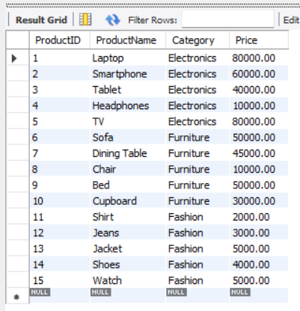

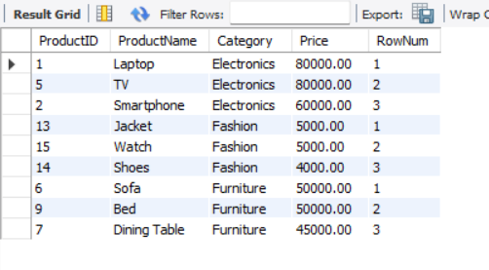

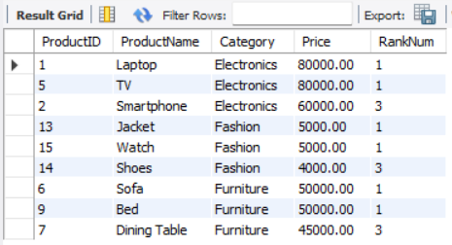

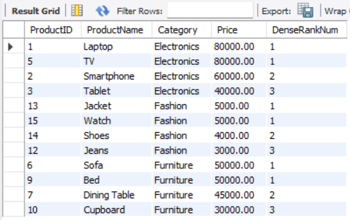

SQL Exercise - Stored procedure
Exercise 1: Create a Stored Procedure
Goal: Create a stored procedure to retrieve employee details by department.

CREATE DATABASE EmployeeManagement;
USE EmployeeManagement;

CREATE TABLE Departments (
DepartmentID INT PRIMARY KEY,
DepartmentName VARCHAR(100)
);
CREATE TABLE Employees (
EmployeeID INT AUTO_INCREMENT PRIMARY KEY,
FirstName VARCHAR(50),
LastName VARCHAR(50),
DepartmentID INT,
Salary DECIMAL(10,2),
JoinDate DATE,
FOREIGN KEY (DepartmentID) REFERENCES Departments(DepartmentID)
);
INSERT INTO Departments VALUES
(1, 'HR'),
(2, 'Finance'),
(3, 'IT'),
(4, 'Marketing');
INSERT INTO Employees
(EmployeeID, FirstName, LastName, DepartmentID, Salary, JoinDate)
VALUES
(1, 'John', 'Doe', 1, 5000.00, '2020-01-15'),
(2, 'Jane', 'Smith', 2, 6000.00, '2019-03-22'),
(3, 'Michael', 'Johnson', 3, 7000.00, '2018-07-30'),
(4, 'Emily', 'Davis', 4, 5500.00, '2021-11-05');*/
SELECT * FROM Departments;
SELECT * FROM Employees;

DELIMITER //

CREATE PROCEDURE GetEmployeesByDepartment(
IN DeptID INT
)
BEGIN
SELECT *
FROM Employees
WHERE DepartmentID = DeptID;
END //
DELIMITER ;
CALL GetEmployeesByDepartment(3);
DELIMITER //

CREATE PROCEDURE sp_InsertEmployee(
IN p_FirstName VARCHAR(50),
IN p_LastName VARCHAR(50),
IN p_DepartmentID INT,
IN p_Salary DECIMAL(10,2),
IN p_JoinDate DATE
)
BEGIN
INSERT INTO Employees
(FirstName, LastName, DepartmentID, Salary, JoinDate)
VALUES
(p_FirstName, p_LastName, p_DepartmentID, p_Salary, p_JoinDate);
END //
DELIMITER ;
CALL sp_InsertEmployee(
'David',
'Wilson',
3,
8000.00,
'2022-06-15'
);

SELECT * FROM Employees;

Output:
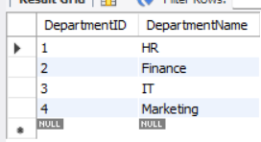
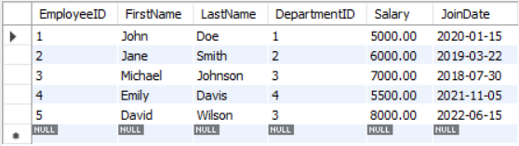

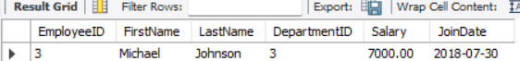

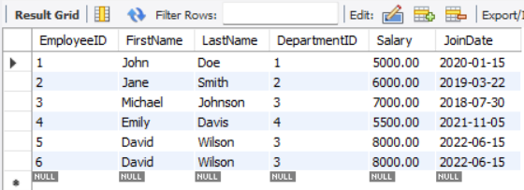

Exercise 5: Return Data from a Stored Procedure

DELIMITER //

CREATE PROCEDURE GetEmployeeCountByDepartment(
IN DeptID INT
)
BEGIN
SELECT COUNT(*) AS TotalEmployees
FROM Employees
WHERE DepartmentID = DeptID;
END //

DELIMITER ;

Output:

